What is a Cosmo?

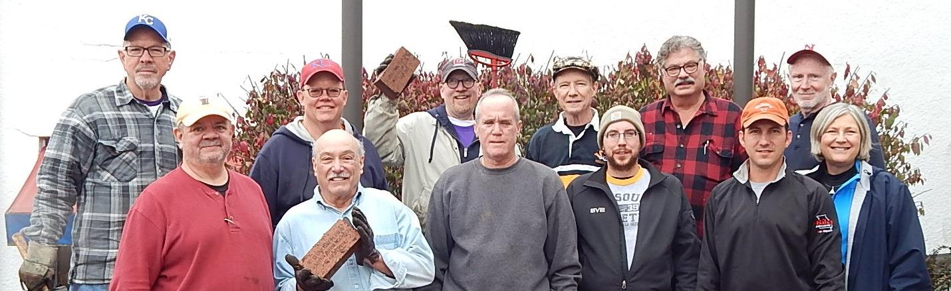
Definition

(1) A person with a passion to raise awareness for diabetes.
(2) An organization that has given $5 million+ toward a cure.
(3) A Cosmo is a friend!

Cosmopolitan International is a chartered not-for-profit civic service organization that was founded in 1918. It consists of some 60 clubs with a membership of approximately 1,800 in the United States and Canada.

Mission Statement

The mission of Cosmopolitan International is to contribute to community well-being through charitable donations and volunteer service with special emphasis on supporting efforts to prevent and find a cure for diabetes.

"What Do You Like About Cosmopolitan?"
- Building Friendships
- Working Together as a Team
- Touching the Lives of People with Diabetes
- Learning New Leadership Skills
Our members develop UNITY by the collective action of the membership within the community for the betterment of all. Through attendance at meetings an activities, Cosmopolitan members enjoy the opportunity to meet new people and develop long-lasting friendships with those who share similar interests. Club events also offer a chance to expand business and professional networking.

Sioux Falls Cosmopolitans - Our Focus

Since 1973, CI has adopted diabetes as its international focus and has branded itself as “the club that fights diabetes”.
The SFCC is and has been involved in many projects over the years. To name a few:
- The band shell at McKennan Park
- American Legion Boys and Girls State
- Crimestoppers
- Great Plains Zoo
- Cosmopolitan Fund for Children (South Dakota 501c3)
- LifeScape and its predecessor organizations
- EmBe (formerly YWCA)
- YMCA Camp Teepeetonka
- Camp Gilbert at NeSoDak Camp near Waubay, SD
Since 1929, the SFCC has presented a Distinguished Service Award to recognize a person in the Sioux Empire for extraordinary community service. The award is based on the philosophy that Cosmopolitan cares not for a person’s wealth, but for their character and values a person’s desire to serve their community and country.
The SFCC raises funds primarily through:
- Sioux Empire Fair: held in early August, we usher for the entertainment in the grandstands;
- Sportsmen’s Show: in late February or early March, we partner with Cenaiko Productions to support ticket sales and provide staff to take tickets and serve as door guards.
- Sweetest Day of Golf: our largest fund-raiser, this one day event is held in September

